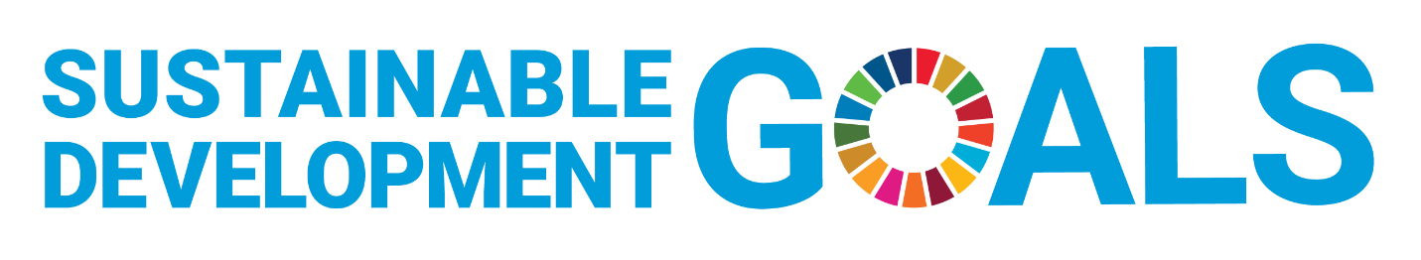

2023-24 Institute for Business Ethics and Sustainability Faculty Opportunity Fund Application

The IBES Faculty Opportunity Fund distributes awards of up to $4,000 each year to faculty members whose research supports PRME Principle #4 and the work of business advancing any the Sustainable Development Goals (SDGs). It is supported by the endowment funds of IBES.

Please complete the application below and submit to ibes@lmu.edu on or before August 18, 2023.

Name _______________________________________________________________

DEFINITIONS AND OVERVIEW

Sustainable Development Goals
At its heart are the 17 Sustainable Development Goals (SDGs), which are an urgent call for action by all countries - developed and developing - in a global partnership. They recognize that ending poverty and other deprivations must go hand-in-hand with strategies that improve health and education, reduce inequality, and spur economic growth – all while tackling climate change and working to preserve our oceans and forests. (https://sdgs.un.org/goals)

SDG Targets and Indicators
The 17 Sustainable Development Goals are defined in a list of 169 SDG Targets. Progress towards these Targets is agreed to be tracked by 232 unique Indicators. (https://sdg-tracker.org/)

PRME Principle #4 – Research
We will engage in conceptual and empirical research that advances our understanding about the role, dynamics, and impact of corporations in the creation of sustainable social environmental and economic value. (https://www.unprme.org/what-we-do)

RESEARCH

Provide a brief description of the research you would be engaged in for the coming year and its impact advancing business knowledge related to PRME Principle #4 and one or more of the SDGs with its related Target and Indicator.

FUND USES

Provide a brief Summary of how Funds will be used (equipment, submission fees, research assistance, data bases, survey costs, etc.

